**A Dimensionality Reduction Framework for Detection of Multiscale Structure in Heterogeneous Networks**

Group-25

R. Vivek

Y. Sai Vignesh

Table Of Contents

1. Introduction
   1. Purpose
   2. Scope
2. Specific Requirements
   1. Performance Requirements
   2. Interface Requirements
      1. Operational Requirements
      2. Software Interface Requirements
   3. System Requirements
      1. Fuctional System Requirements
      2. Non Functional System Requirements
3. System Specification
   1. Architecture Diagram
   2. Class Diagram

1. Introduction

Most existing methods investigate the community structure at a single topological scale. However, the community structure of real world networks often exhibit multiple topological descriptions and

Heterogeneous distribution of node degree. In our framework, we propose a novel , unified framework to detect multi scale community structure in heterogeneous networks from the perspective of dimensionality reduction.

2. Problem Definition

Graph Clustering and other existing methods have been widely applied in exploring regularities in relational data . These methods investigate the community structure at a single topological scale .

Furthermore, the reduction of multiscale community structure is heavily affected by the heterogeneous distribution of node degree. The covariance matrices such as the laplacian matrix for network partition and modularity matrix for community detection which were used in dimensionality reduction failed to deal with heterogeneous node degrees.

Eigen values and Eigen vectors were unable to effectively deduce the number of communities and identify the different topological scales.

Earlier methods for community detection used hierarchial clustering which involved producing a dendrogram and obtaining the communtity structure by choosing the best place to cut the dendrogram,

but this optimization proved to be NPhard.

The aim of this project is to detect communities at multiple topological scales within our framework and to handle heterogeneous networks by introducing a rescaling transformation into the covariance

matrices and by demonstrating that the proposed corelation

matrices outperform the covariance matrices.

* 1. Document Purpose

This SRS describes the functions and performance requirements of plugin which is used generate the scalable and compact sequence diagrams. The goal of this project is to show how scalable visualizations can be achieved by compact representation of sequence diagrams without compromising on the meaning which reduces the complexity to analyze the program behavior.

* 1. Scope

Scope of the project is to identify communities, i.e. areas of a graph that are more densely connected than other parts of the graphs in multiple topological scales.

2. Specific Requirements:

2.1 Performance Requirements

* There must be proper datasets of the graph on which we are implementing the algorithms.
* The node taken into consideration for finding the eigen values and the eigen vectors must be selected carefully.

2.2. Interface Requirements

2.2.1. Operational Requirements

* After finding the Eigen values and the corresponding Eigen vectors, graph plots must be plotted in the editor accordingly.
* The packages required for developing the python code for Data computations must be present implicitly.

2.2.2. Software interface requireme

Proper Windows and Ubuntu platforms for implementing python codes and importing required packages.

**2.3. System Requirements**

2.3.1. Functional Requirements

* Enable users to view the input dataset as a graph. The system reads the input dataset and returns the nodes separated into communities.
* Viewing visually aided graph plots. Users can view the desired results and graphs through the editors.

2.3.2. Non-Functional Requirements

* Compatibility: Compatible with Windows and Linux platforms.
* Ease to use: Huge data can be divided into clusters through this perfectly.

**Architecture Diagram**

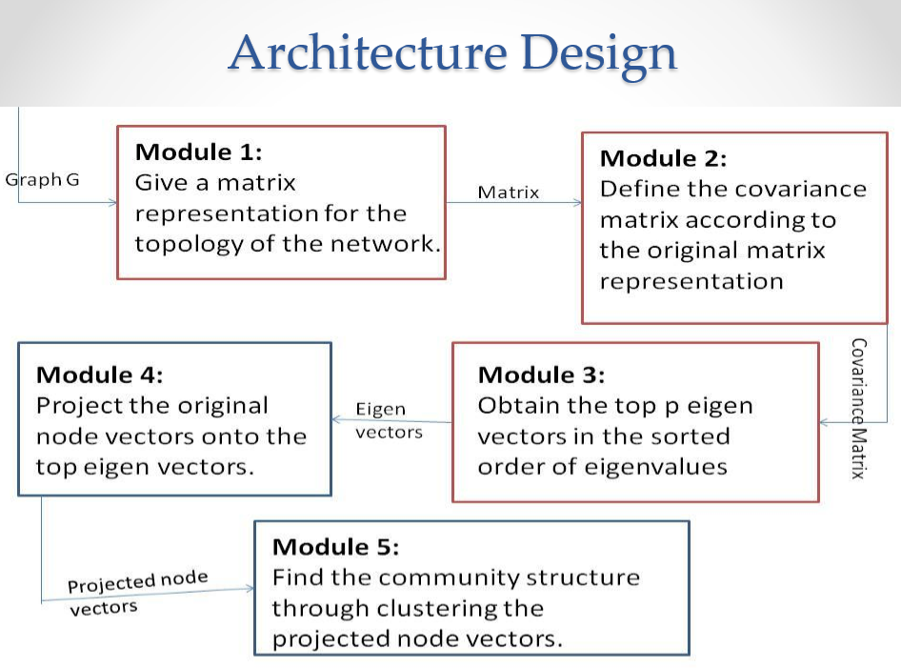

**Class Diagram**

